Georgia State Parks and Historic Sites
Weekend Summary
05.11.2020

Crowds:
- Some sites saw more moderate day use visitation on Saturday, than last weekend, in part due to much cooler temperatures. However, many sites still had high levels of day use and hiking, as well as overnight use. Sites that temporarily limited day use access to ensure social distancing included: Black Rock, Chattahoochee Bend, Cloudland Canyon, Ft. Yargo, High Falls, James H. Floyd, Mistletoe, Providence, Red Top, Sweetwater, Tallulah Gorge, Vogel and Wormsloe. Many other parks had high visitation including Watson Mill Bridge and F.D. Roosevelt.

- Golf Course activity
Golf courses continue to be busy and a substantial improvement over last year, having a 15% increase this past week.

- Boat ramp activity
Most boat ramps were at normal to busy weekend levels in part due to cooler temperatures and windy conditions. The boat ramp adjacent to the George L. Smith park office experienced crowding issues.

Staffing issues:
- As of today, the Division as a whole has 86 part-time and full-time staff out due to COVID-19 related reasons. Staff that were isolating are now coming back to work or making plans to return this month. A total of 41 Camp Host Units have left due to COVID-19 and 34 units have been replaced.

Positives
- Although most parks were very busy this weekend, the modified operation plans are working effectively. Other measures are assisting as well including: sharing staff from other sites, social media updates, operating Kiosks, and assistance from LED Game Wardens. Georgia State Patrol assisted Providence Canyon State Park with heavy traffic issues at the park gate on Saturday and Sunday.

- Few sites report social distancing issues this week, with the noted exception of Fort McAllister which experienced more issues than in previous weeks due to increased day use.

- The new Social Distancing video released on Saturday has already had almost 14k views.

- The eRanger initiative continues to be a huge success. Click here for one of the posts from this week. This page week there were 495 views on the webpage, 144,200 views on facebook and 870,700 since it launched March 25. There have been 822 views on YouTube and 2,938 since the launch. Website statistics for 5/4–5/11:
  - Total Pageviews 1.8 mil- up 135% YoY
  - Reservations page 37k - up 84% YoY
  - Alerts Page received 24,880 views

Challenges
- Keeping the public in compliance per the EO on social distancing through the modified operation plans is ongoing, but working smoothly overall. Key staff are working most every weekend and staff sharing is working to keep the sites covered.

- Keeping people off playgrounds continues to be an issue, with signs, caution tape, and at times even park staff being ignored.

- Wormsloe has experienced trespassers after hours and visitors not wanting to pay the entry fee.

- Laura Walker found a counterfeit $100 bill in the collection box - Ware County is investigating as part of a larger issue in the area.

- Fort King George experienced high visitation with numerous guest issues including people harassing an alligator, dogs off leash, littering, and payment of fees in the honor box.

- Visitors pried open the soap dispensers in the day use restrooms at Fort McAllister and stole the liquid soap along with the toilet paper.

- Guests are very frustrated once parks reach capacity continue to verbally abuse kiosk workers and other staff at front gates primarily at Sweetwater Creek, Fort Yargo, and Mistletoe. One individual refused to move at Fort Yargo and caused traffic to back up onto the highway. DNR LED instructed the individual to move and he moved across the street in a neighborhood. At that point he called local LE to file a complaint on the park manager for not allowing him in the park. Winder PD responded and spoke with the park manager and then spoke to the gentleman across the street.

- Neighborhood parking continues to happen at Sweetwater Creek and Fort Yargo. Sweetwater Creek has received several complaints for local neighbors on guests parking in their neighborhood. This site also received a complaint from a Douglas County Deputy for traffic backing up on Mt. Vernon after the site reopened. This deputy stated he was taking his complaint to the Douglas County Commissioners. A better plan was put in place for Sunday and traffic was reduced on Mt. Vernon. Guests continue to circle park entrances at Sweetwater Creek, Red Top, and Fort Yargo waiting for the gates to open. This has also increased traffic on local roads around these sites.

Weekend Occupancy:
Past Weekend:
Our overall occupancy for all reservables increased 22% this past weekend. This is the second weekend in a row since COVID started that the overall weekend occupancy has increased. Last weekend we saw a 7% occupancy increase. Cottage rentals continue to return, as we were at 76% occupancy this past weekend for the second weekend, and only at a 2% decrease from the previous year. Camping continues to see high occupancy, reaching 88% this past weekend. This is up 29% from the same weekend last year. Yurt occupancy was at 92%, or 11% higher than last year.

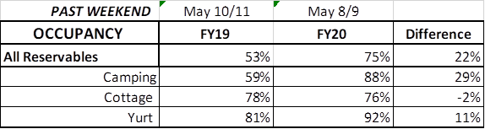

Upcoming Weekend:
For the upcoming weekend, we are seeing a 1% decrease in all reservables. Last week at this point, we were up 20% over the previous year. Camping is showing a 6% increase over last year, up to 88% occupancy. Cottages are showing a 18% decrease compared to the same weekend last year. For this upcoming weekend, yurts are already 99% booked. This is up 16% over last year.
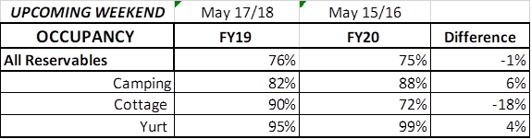

Revenue:
For the month of March through May 10th, we have seen a decrease in revenue of 14% or a loss of $1.1 Million. This past week, May 4th – May 10th, we actually saw a 47% or $380,000 increase in overall revenue. This is the fourth week in a row our revenue has increased since the COVID situation began, and the second week our increase was over 45%.
For overnight accommodations – camping revenue has now increased 40%, over $1 Million. This past weekend it increased 159% or $325,000. This is the 4th week in a row the revenue has more than doubled. Cottages also saw a significant increase this past weekend, and are now only at a 18% or $343,000 loss during this time period; yurts are now seeing a 4% increase over last year.
ParkPass has decreased 4% or $35,000 during this timeframe. This past week is the second week we have seen an increase in ParkPass revenue. Due to the opening of the Kiosks and the beautiful weather, ParkPass jumped 60% or $54,000 this past week.
Golf continues to see a substantial improvement over last year, having a 15% increase this past week. During COVID, golf revenue has increased 10% or $42,000.
The revenue continues to significantly improve over last week due to several reasons:
- In early April we changed policy from collecting only a one-night deposit when booking a reservation, to collecting all revenue at the time of booking. This is the reason for the significant increase to camping and yurt revenue, and that cottage revenue is starting to rebound. This will have an effect on future revenue collections and the amount of refunds given.
- Camping occupancy has actually improved over the previous year for the 4th weekend in a row, with a significant increase last weekend at 29%.

- And again, the number of cancellations is starting to significantly slow down. Although we do need to keep in mind, that for future refunds, we will be refunding the revenue for the entire stay, rather than just a one-night deposit.

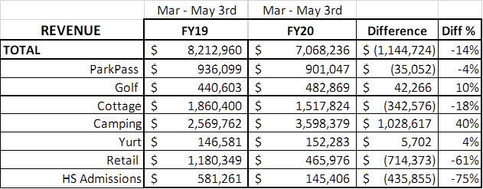
Cancellations/Refunds:
Through this morning, we have had 24,450 cancellations, including $2.1 Million in actual refunds and a loss of future revenue of $8,250,000.
This is 1,150 more than last Monday, when we were at 23,300 cancellations. The significant drop in the number of cancellations continues, as initially we had 4,000 – 5,000 a week. Last year during the same week we had approximately the same number of cancellations, so hopefully we are starting to get back to normal…which is great news!!!
Last year during the March thru YTD, we had 7,600 cancellations, including $372,000 in actual refunds and a loss of future revenue of $1.8 Million.
So, total cancellations have increased over 16,850 or 221% and the amount of refunds have increased $1.7 Million.

